ITA MicroFund 2022 Application Questions
Applicant Information
Applicant Name*

Signing authority name (if different from above)

Signing authority number (if different from above)

Are you 51% Indigenous owned?*

Business number:

Have you been approved for any funding for this year from other agencies?*

If "yes", how much funding have you received?

What is the primary type of tourism-related product or attraction you currently offer?
  - Accommodation
  - Culinary
  - Cultural Centers/ Museums
  - Guided Tours
  - Events (including festivals and Pow Wows)
  - Art Gallery/ Artisan
  - Other
If other, please explain

Business Information
Year business was established*

Best phone number to best reach you*

Is the business wholly or majority-owned (51%) by Indigenous women?*

Indigenous business type*
  - Corporation
  - Cooperative
  - Non-profit
  - Partnership
  - Other
If other, please explain
In the last year, how many employees did your business employ at peak season?

Business website

What social media platforms does your business currently participate on?
  - Facebook
  - Instagram
  - LinkedIn
  - Twitter
  - YouTube
  - TikTok
  - Other
If other, please explain

What stage of operation readiness is your business currently at? (As per your ITA membership)
  - In-development
  - Visitor-ready
  - Market-ready
  - Export Ready

Are you an active member of Indigenous Tourism Alberta?*

In the past year, have you been involved with any ITA programs? If so, please list which ones.*

Does your business offer visitor tours in both official languages (English and French)

Does your business offer visitor tours in other languages? If so, please list*

Please enter the best email address for correspondence regarding this application. This is especially important for people submitting for multiple businesses.

Does your business have a plan in place to adapt for post-COVID-19 recovery?*

Is your business currently tracking financial losses from cancellations due to COVID-19?*

If you are tracking financial losses, what is the estimated amount of financial loss for your business in 2021 due to COVID-19?*

Has your business had to decrease the number of employees for this season as a result of COVID-19?*

Based on current bookings for 2023, do you anticipate that you will be able to return to pre-COVID-19 staffing levels?*

Will you access other federal or provincial support to assist with COVID-19 recovery?*

Would you like to receive more information about COVID-19 recovery resources?*

What are the important economic stimulus measures necessary to assist the Indigenous Tourism operators post-COVID-19 recovery?*
  - Stimulus Funding
  - Access to interest- free business loans
  - Payment deferrals for mortgages or lines of credit
  - Employee subsidy programs
If you selected other, please list here

Proposed Priority
Have you won any awards or received any significant recognition for your Indigenous tourism attraction or experience? If so, please describe the type and date of the recognition received*

Choosing a Category:
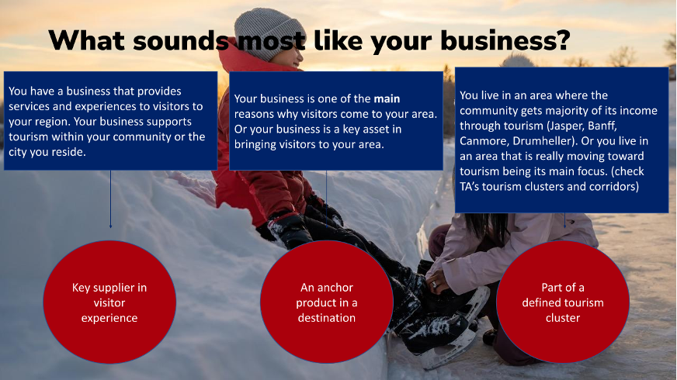
Category Chosen:

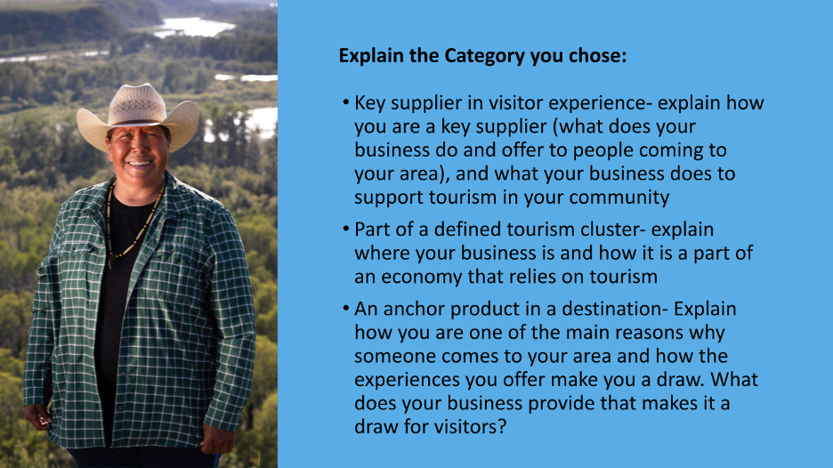
Explain why you chose that category:

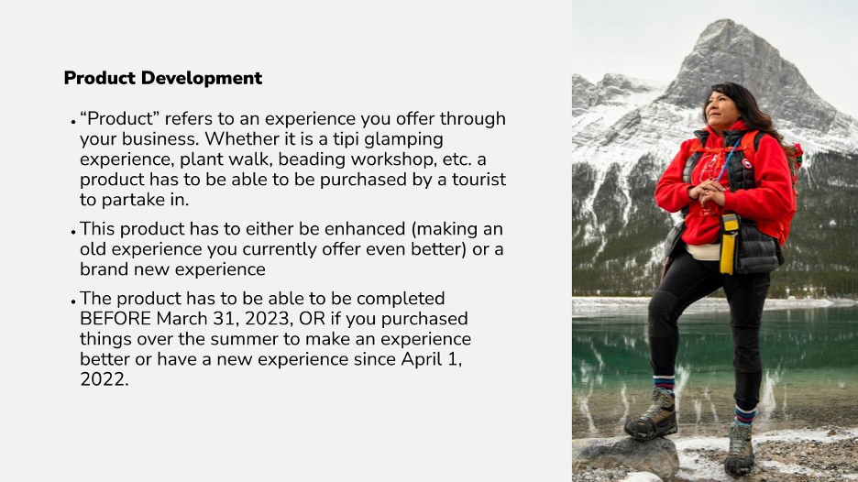

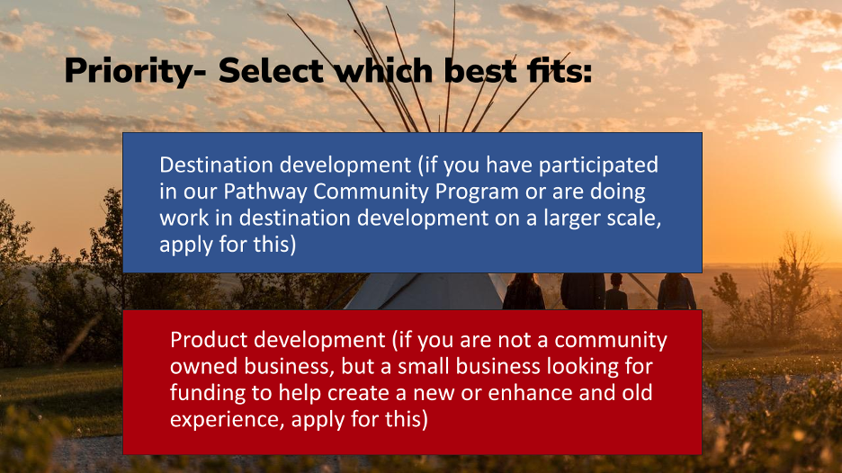
Which priority do you choose:

From the two priorities, describe how projects objectives, activities and outcomes fit the priority you selected. (Product Development or Destination Development)

- How will this funding help you create a new product or enhance an existing?
- Are you purchasing new equipment? Are you paying staff (or have paid staff over the summer) to facilitate a new experience?
- What do you plan on doing with this funding to create or enhance your experience?

Project Description / Executive Summary
● The following are questions we suggest you ask yourself and record the answers to. You can then take these answers and combine them for your project description.

Your current state: what have you/your business accomplished so far?

What is the new product you want to create, or what are the things you want to do to your current experience to make it even better?

What assets (materials, staff, infrastructure) do you need for this project? And what do you need to do in order to make this project come to life?

What are the costs of the assets you need for this project? This will be put into PROJECT COSTS.
Please list project costs. Be sure to list costs and not activities. Please summarize the various major project costs. The total amount MUST be the same as the amount of funding you are asking to receive.
Do you need:
- Any materials for operation of this project
- Equipment?
- Any staff or contracting?
- Website enhancements?
- do you need a booking engine for people to book your experiences?
- Infrastructure? (define infrastructure)

What are the steps you’ll take (or you have taken) to accomplish the project?
- Have you signed a land lease agreement?
- Have you hired staff over the summer for this project?
- Have you purchased anything over the summer that is related to this project?

Describe how this grant will support recovery for your business (example: number of jobs, recovery of revenues for the business and/or impact of being more market/export ready)

What will be the end result once the project is complete?
  - What are your end goals?
  - Will you increase your revenue? If so, by how much?
  - Will you be able to offer more experiences? If so, how much?
  - Will you be able to hire more staff? If so, how many?

How long will it take for you to complete the project?

What are the expected outcomes (to help stabilize after covid)

How will this funding help you become a stronger business and recover post COVID-19?

Do you currently have community for other funding support for this project?

Please ensure when filling out your MicroFund Applciation, that you also mention how this project will help increase your market or export readiness (see the Development Matrix and ITAC National Guidelines to learn about growing your business to a market or export ready level).

As an industry, what type of support do you feel ITA should be focusing on in order for your business(es) to overcome the current issues*
  - Stimulus Funding
  - Online education webinars on tourism development
  - Online education webinars based on marketing your business
  - Health and safety information
If other, please list here

What do you believe are some of the strengths of your business*

Tourism Industry Reference #1
Business Name*
Contact person*
Contact phone number
Relationship to your business*
Tourism Industry Reference #2
Business name*
Contact person*
Contact phone number*
Relationship to your business*

