CONTACT & BUSINESS INFORMATION:
Business Name:
Contact Name:
Email:
Phone:

BASIC MARKET READY STATUS
Please review this basic market-status information.
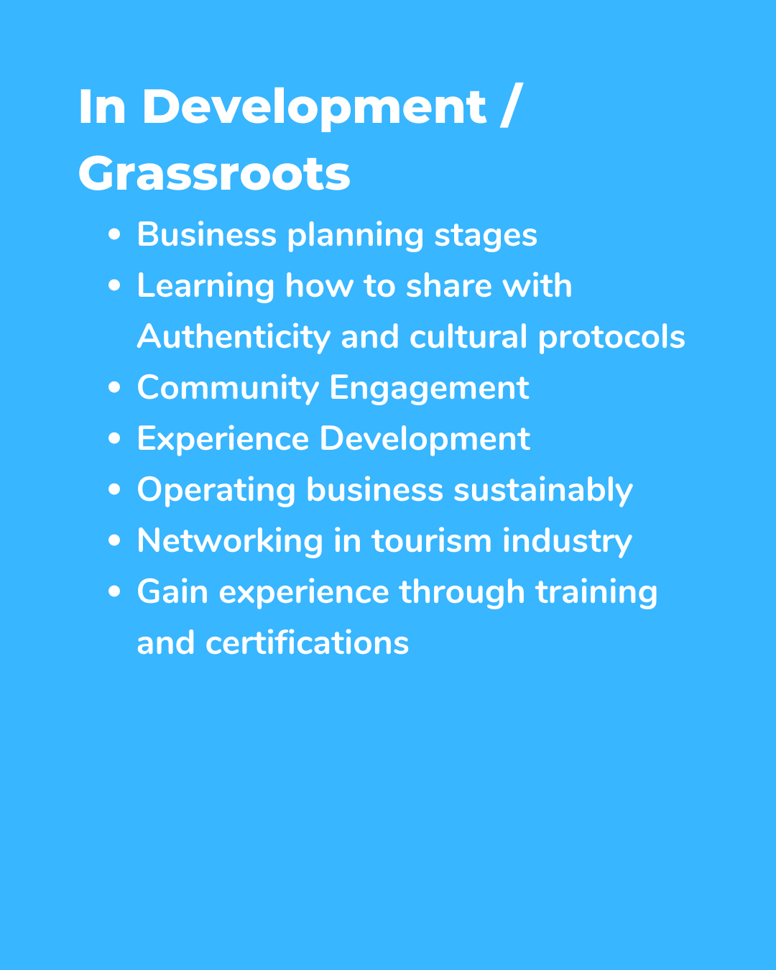 | 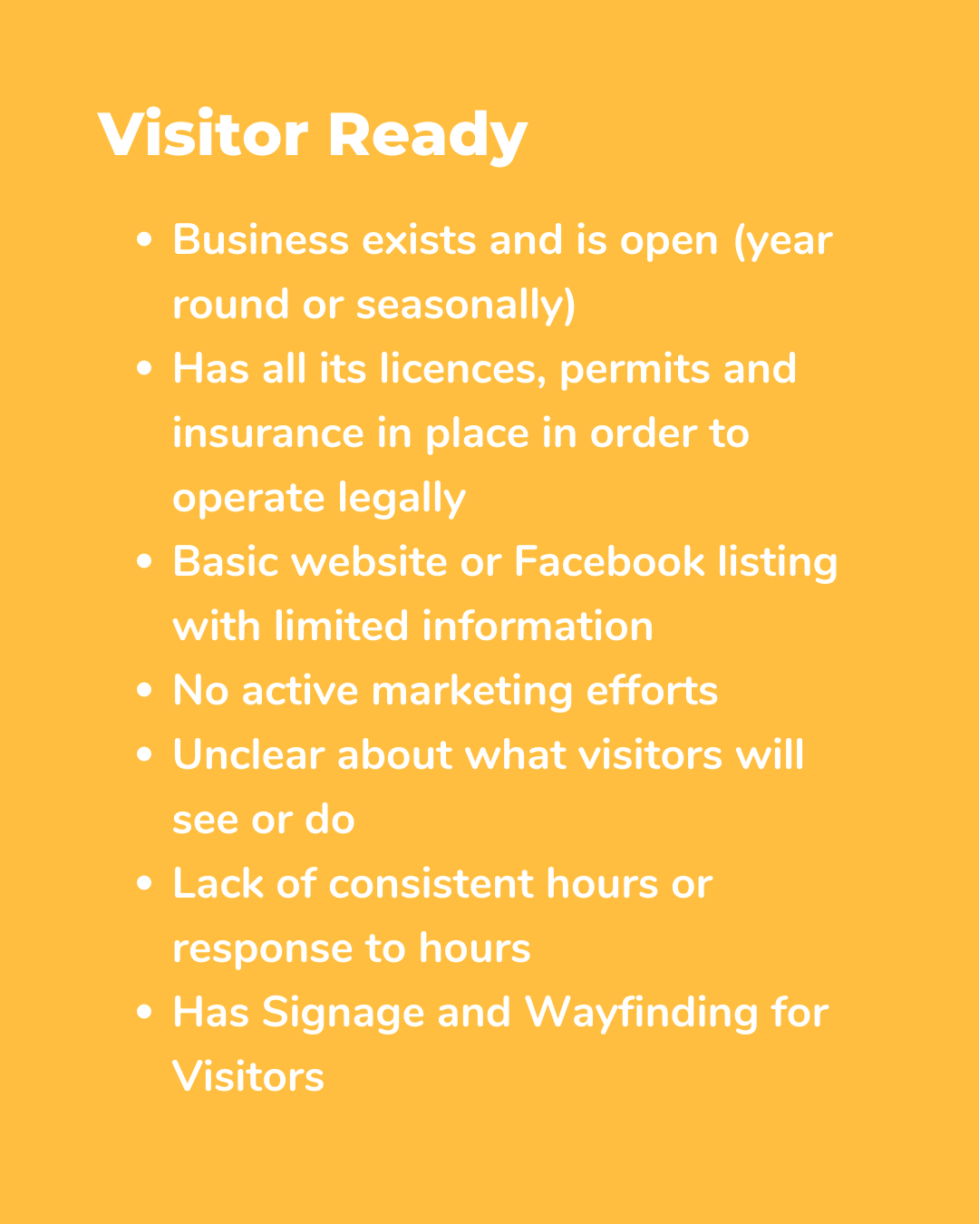
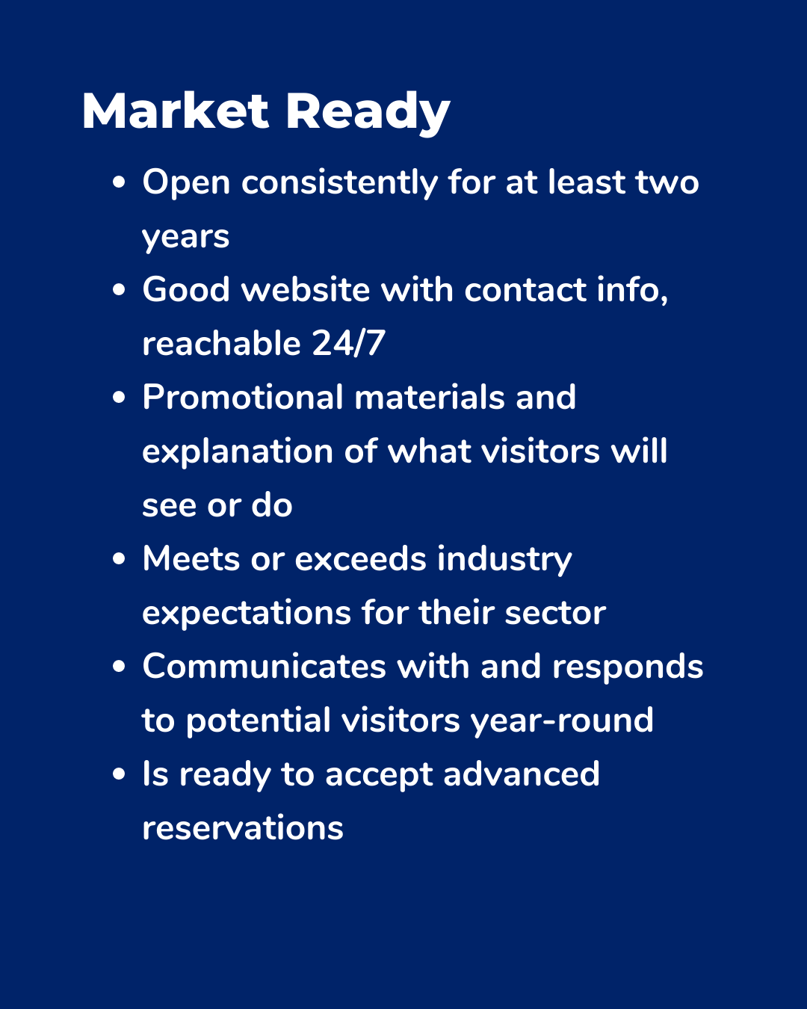 | 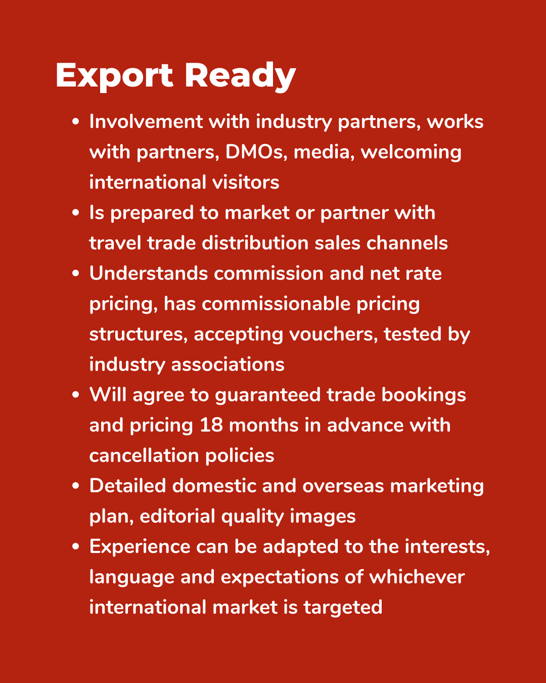

DESCRIPTION OF PRODUCTS OR EXPERIENCES OFFERED:
Based on the above guidelines please indicate which market preparedness category you feel you fall into: | - In development/grassroots  - Visitor ready  - Market ready  - Export ready
Please check all that apply: | Your business currently has:  - The correct business licenses and permits to operate your business and current experiences  - Has operating tourism facing website for your business  - Returns emails and phone calls within 24 hours  - Has a consistent experience you are currently offering

PROGRAM APPLICATION QUESTIONS:
Why do you want to join the ITA Strengthening Our Roots Program?
*(suggested word count: 250-400 words)

How do you feel this program will benefit your Indigenous tourism business? What particular areas are you looking to put into place and/or strengthen when it comes to your tourism business (eg. operations, insurance, and business infrastructure)? Please provide specific examples.
*(suggested word count: 200-400 words)

DESCRIPTION OF YOUR CURRENT INDIGENOUS TOURISM BUSINESS:
Please describe your current Indigenous Tourism Business and how you hope to enhance and grow your business during this program.
*(suggested word count: 250-400 words)

GOALS & OBJECTIVES
Please check all that apply: | “Within the next year I hope to:”  - Further strengthen my current business plan and infrastructure  - Building an Indigenous tourism based website  - Invest more in marketing for my business  - Increase my market preparedness and take my business to the next level  - Enhance and create new experience offerings for my business

What is your business plan for the next 12 months? Please describe how you would like to grow your business over the next 12 months (ie. How would you like things to be different a year from now?)
*(suggested word count: 300+words)

TIME COMMITMENT
Please check all that apply: | - Are you able to commit to the approximate 2 hours per week on business development and Mentoring sessions, starting in October, 2023

